Connect Mikrotik to Modem

09 Aug 2025

Topology

Think:

* Make Mik Connect to Modem (SSID and password)
* Mikro Wen1 need to get the internet from Model
* Now we have internet in Mikrotik we want to provide the DHCP server to port ether2 to PC
* In Mikrotik need to have Nat to translate DHCP server to internet

1. Enable Wan

1. Connect Wen1 to Modem Wifi

1. Setup Security password

Password need to be the same our modem wifi pass

1. Scan and connect to wifi modem

1. After we connect to Modem we need to get the DHCP from the modem

Status connection bound: then we can ping to the internet

1. Set up port the in Mikrotik to share the internet to computer

Create DHCP server

Prepare our Ip rang that we want the DHCP server to share on which port:

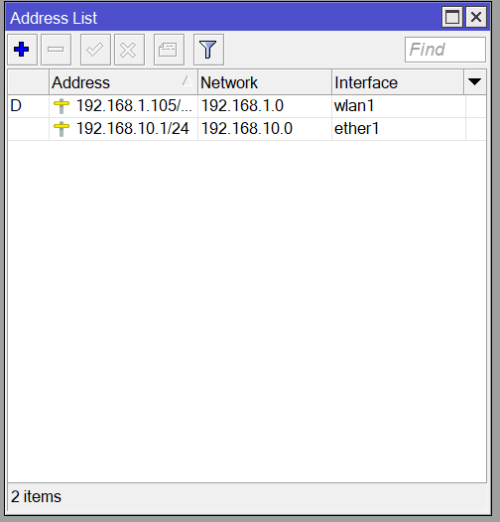

1. Setup DHCP server

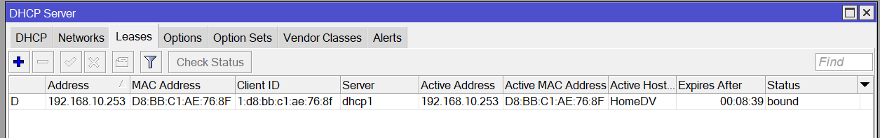

1. Setup NAT

Now we can ping to the internet from PC !